Centre Integrat de Formación Professional Pau Casesnoves
Task for BD04
Bases de Dades (DAM_BD)
Luis Ulises Quinteros Quinteros
22-2-2026

Index
Exercise 1 2
Exercise 2 4
Exercise 3 4
Exercise 4 5
Exercise 5 6
Exercise 6 6
Exercise 7 7
Exercise 8 7
Exercise 9 8
Exercise 10 8

USE classicmodels;
/*

Exercise 1
*/
/*
Insert a new record in the customers table using the graphical tool offered
by MySQL Workbench. The data must be the following:
Field Value
customerNumber 500
customerName Stellar Tech Ltd.
contactLastName Rivers
contactFirstName Julia
phone +34 600123456
addressLine1 99 Innovation Rd.
addressLine2 NULL
city Barcelona
state NULL
postalCode 08018
country Spain
salesRepEmployeeNumber 1056
creditLimit 75000.00
*/
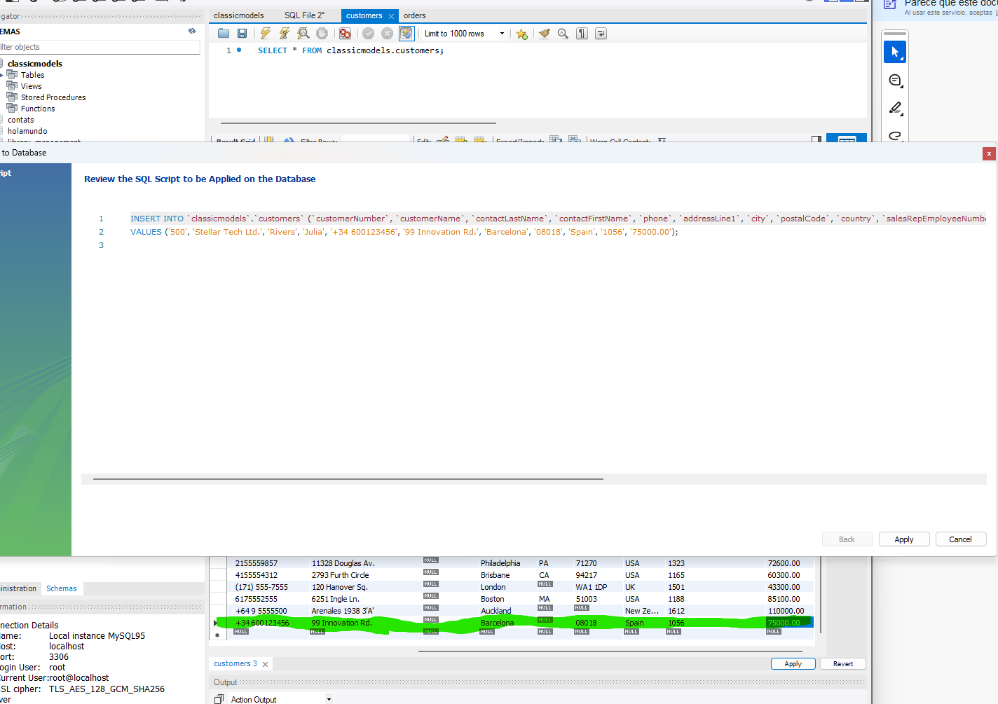

Data entry for the new record in the grid editor before clicking the 'Apply' button.

/*
Insert a new record into the employees table using the graphical tool. The data must be:
Field Value
employeeNumber 2001
lastName Ortega
firstName Marc
extension x201
email marc.o@classicmodels.com
officeCode 1
reportsTo 1002
jobTitle Sales Rep
You must provide screenshots of the data insertion process and the moment before
applying the changes. Describe each capture briefly.
*/
Review of the SQL script automatically generated by MySQL Workbench before final execution

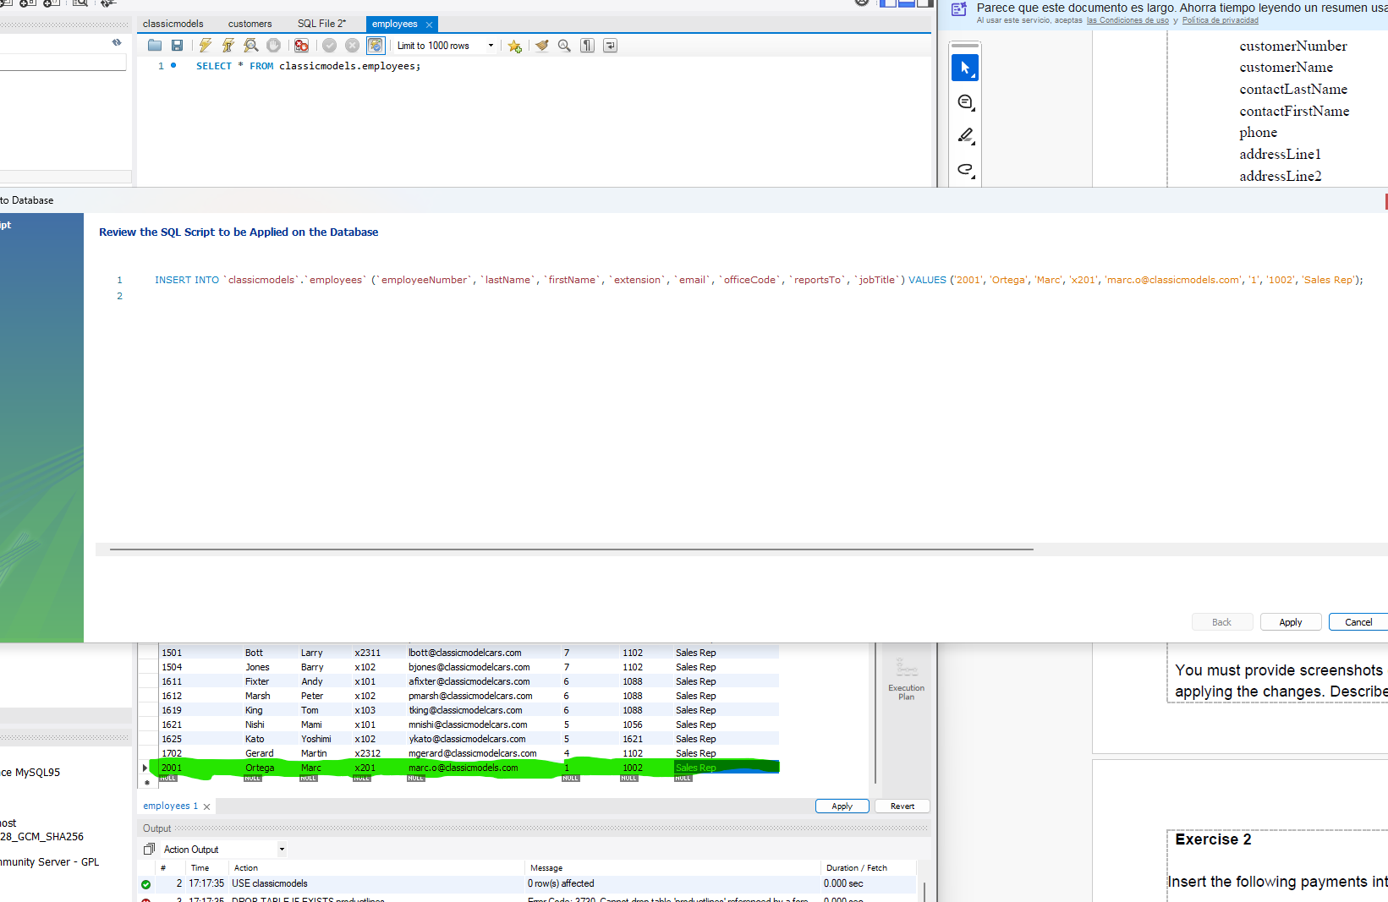

/*

Exercise 2

Insert the following payments into the payments table using SQL statements:
customerNumber checkNumber paymentDate amount
124 H123 2024-02-06 845.00
151 H124 2024-02-07 70.00
112 H125 2024-02-05 1024.00
Copy the SQL statements you used in your submission. Only include the data shown.
*/
INSERT INTO payments VALUES (124, 'H123', '2024-02-06', '845.00'),
(151, 'H124', '2024-02-07', '70.00'), (112, 'H125', '2024-02-05', '1024.00');

/*

Exercise 3
Modify the addresses of some customers using the graphical tool, and provide
screenshots showing the changes made. Update the records in the customers table as
follows:
customerNumber city addressLine1 postalCode
141 Girona 43 State St 17001
124 Lleida 2 Walls St 25002
119 Tarragona 46 Marlborough Rd. 43003
*/

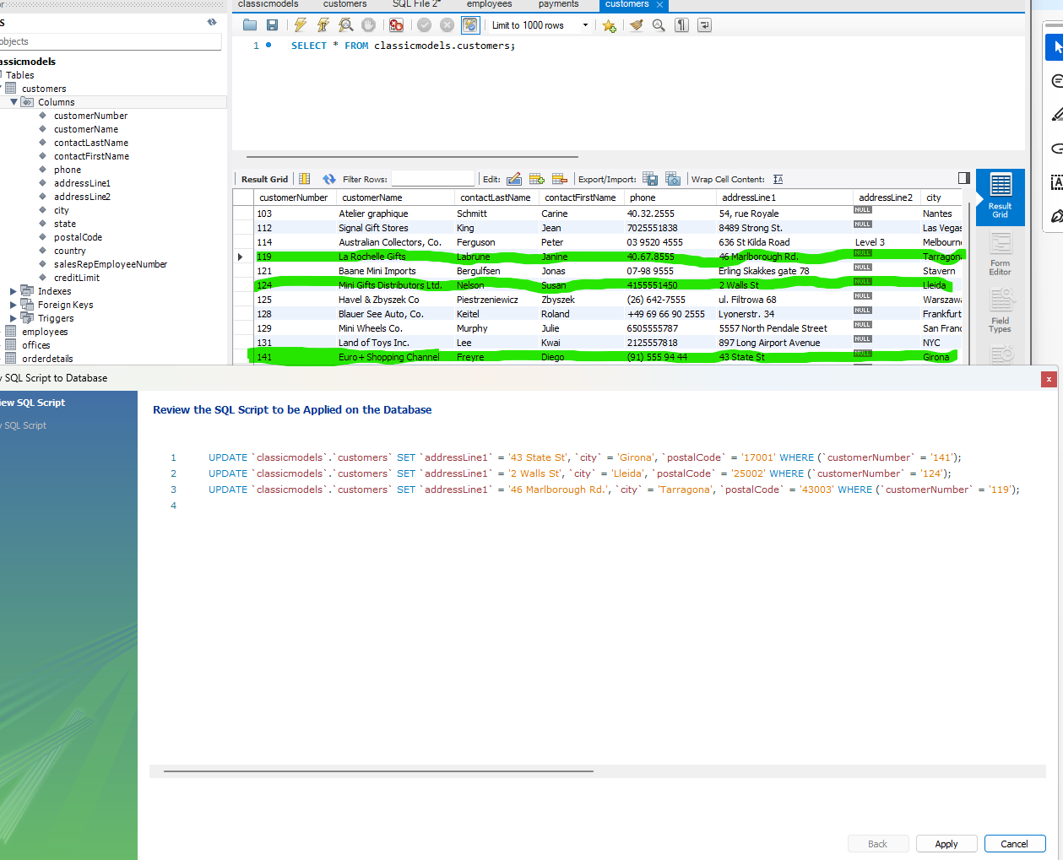
/*

Exercise 4
Cancel the order made on 2003-09-28, using SQL instructions. Change the status to
'Cancelled', the shippedDate to the current date, and comments to 'Order cancelled due
to delay'. Do this using a single SQL statement.
Copy the statement in your submission.
*/
SET SQL_SAFE_UPDATES = 0; /* Take off the safe mode that deny to UPDATE or DELETE anything without PK in WHERE*/
UPDATE orders SET status = 'Cancelled', shippedDate = curdate(),
comments = 'Order cancelled due to delay' WHERE orderDate = '2003-09-28';

/*

Exercise 5
Update all product names of type Trains to include the product code in parentheses. For
example, a product with productCode = S10_1949 and productName = "Vintage Train"
will become:
"Vintage Train (code S10_1949)"
Do this with a single SQL statement using the proper MySQL functions.
Resource: MySQL functions - W3Schools
*/
UPDATE products SET productName = CONCAT(productName, ' (code ', productCode, ')') WHERE productLine LIKE '%Trains%';

/*

Exercise 6
Increase buyPrice and MSRP of all products with quantityInStock > 500 by 0.02%.
Do this with one SQL statement.
*/
UPDATE products SET buyPrice = buyPrice *1.0002, MSRP = MSRP *1.0002 where quantityInStock > 500

/*

Exercise 7
Remove all payments made by customers who are represented by employees with the
last name 'Patterson'.
Use a single SQL statement and copy it for the task delivery.
*/
DELETE pay FROM payments pay JOIN customers cus
ON pay.customerNumber=cus.customerNumber
JOIN employees emp ON cus.salesRepEmployeeNumber=emp.employeeNumber WHERE emp.lastName = 'Patterson';

/*

Exercise 8
Delete all customers from Lisbon who have not made any payment.
Use one SQL statement only.
*/
DELETE cus FROM customers cus LEFT JOIN payments pay
ON cus.customerNumber=pay.customerNumber
WHERE city = 'Lisboa' AND pay.customerNumber IS NULL;

/*

Exercise 9
Add all customers as new employees, using their contact names as first and last name.
Use customerNumber + 2000 as the new employeeNumber, leave all other fields as
'x0000' extension, 'new@company.com' email,'1' officeCode, 'Sales Rep' jobTitle
Use contactFirstName as firstName, contactLastName as lastName.
Do this with a single SQL statement.
*/
INSERT INTO employees (employeeNumber,lastName,firstName,extension,email,officeCode,jobTitle)
SELECT customerNumber+2000, contactLastName, contactFirstName, 'x0000', 'new@company.com', '1', 'Sales Rep'
FROM customers;

/*

Exercise 10
Cancel all orders made by customers handled by the customer Elizabeth Lincoln.
Change the status to 'Cancelled', shippedDate to the current date, and comments to
'Order cancelled by management'.
Use a single SQL statement.
*/
UPDATE orders ord JOIN customers cus
ON ord.customerNumber = cus.customerNumber
SET ord.status= 'Cancelled', ord.shippedDate = curdate(), ord.comments ='Order cancelled by management'
WHERE contactFirstName LIKE '%Elizabeth%' AND contactLastName LIKE '%Lincoln%';

